TASK 5:HOW TO INSTALL A PACKAGE IN PUPPET SLAVE

1 Go to manifests folder /etc/puppetlabs/code/environmen ts/production/manifests/ cd /etc/puppetlabs/cod e/environments/produ ction/manifests/ 2 Create a file site.pp sudo vi site.pp 3 Go to puppet agent and run the manifests sudo /opt/puppetlabs/bin /puppet agent -t 4 If getting an error certificate doesn’t match private key delete the certificate from the agent cd /etc/puppetlabs/pup pet/ssl/certs/ sudo rm -rf 5 Delete the certificate from master sudo /opt/puppetlabs/bin /puppetserver ca list --all sudo /opt/puppetlabs/bin /puppetserver ca clean –certname

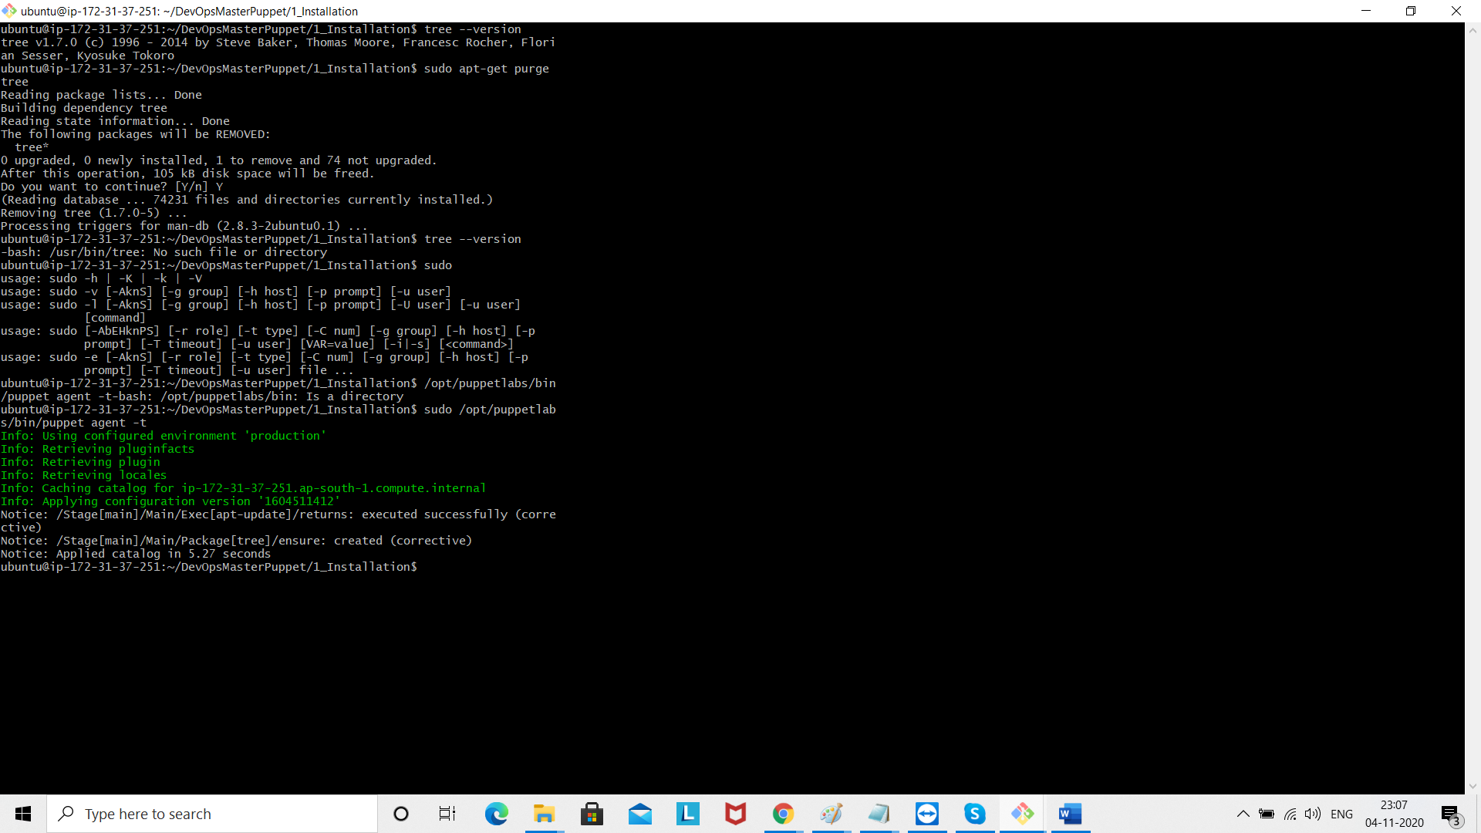

6 Run the puppet agent run sudo /opt/puppetlabs/bin/ puppet agent -t 7 sudo /opt/puppetlabs/bin /puppetserver ca list 8 sudo /opt/puppetlabs/bin /puppetserver ca sign --all 9 sudo /opt/puppetlabs/bin /puppet agent -t